David Friend
CS 255
Professor Lippincott
Southern New Hampshire University

System Design Template
DriverPass System Design Document

This document completes the DriverPass system design by including the required UML diagrams and the technical requirements for the proposed system. The design supports DriverPass’s goal of helping customers prepare for driving tests, schedule driving lessons, and manage account information through a secure online system.

UML Diagrams

UML Use Case Diagram
The use case diagram shows the main groups of people and outside systems that interact with DriverPass. The system supports customers, the secretary, instructors, the owner, the IT administrator, and DMV updates. It includes account access, package purchases, lesson scheduling, practice tests, report review, and system administration.
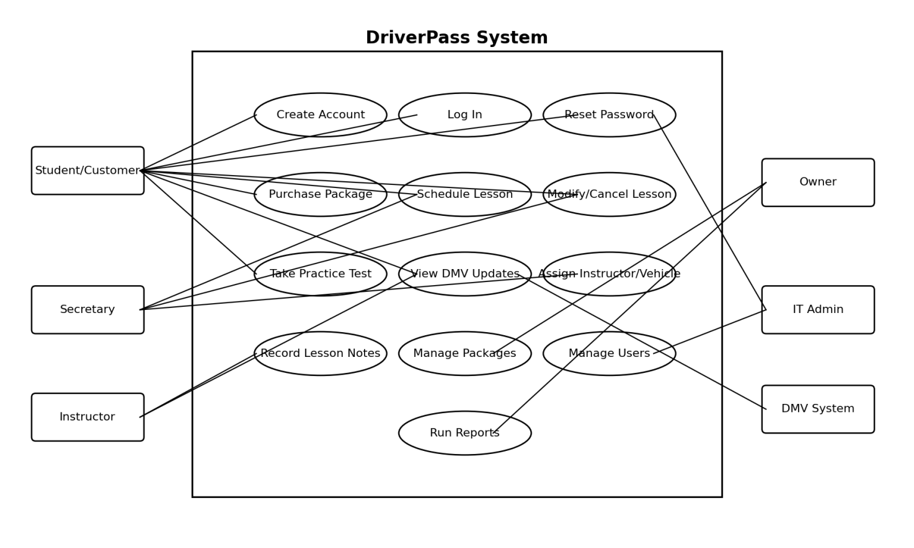
Figure 1. UML Use Case Diagram for DriverPass

UML Activity Diagrams
The first activity diagram breaks down the process for scheduling a driving lesson. This process is important because DriverPass needs students and office staff to be able to book lessons while avoiding conflicts with instructor and vehicle availability.
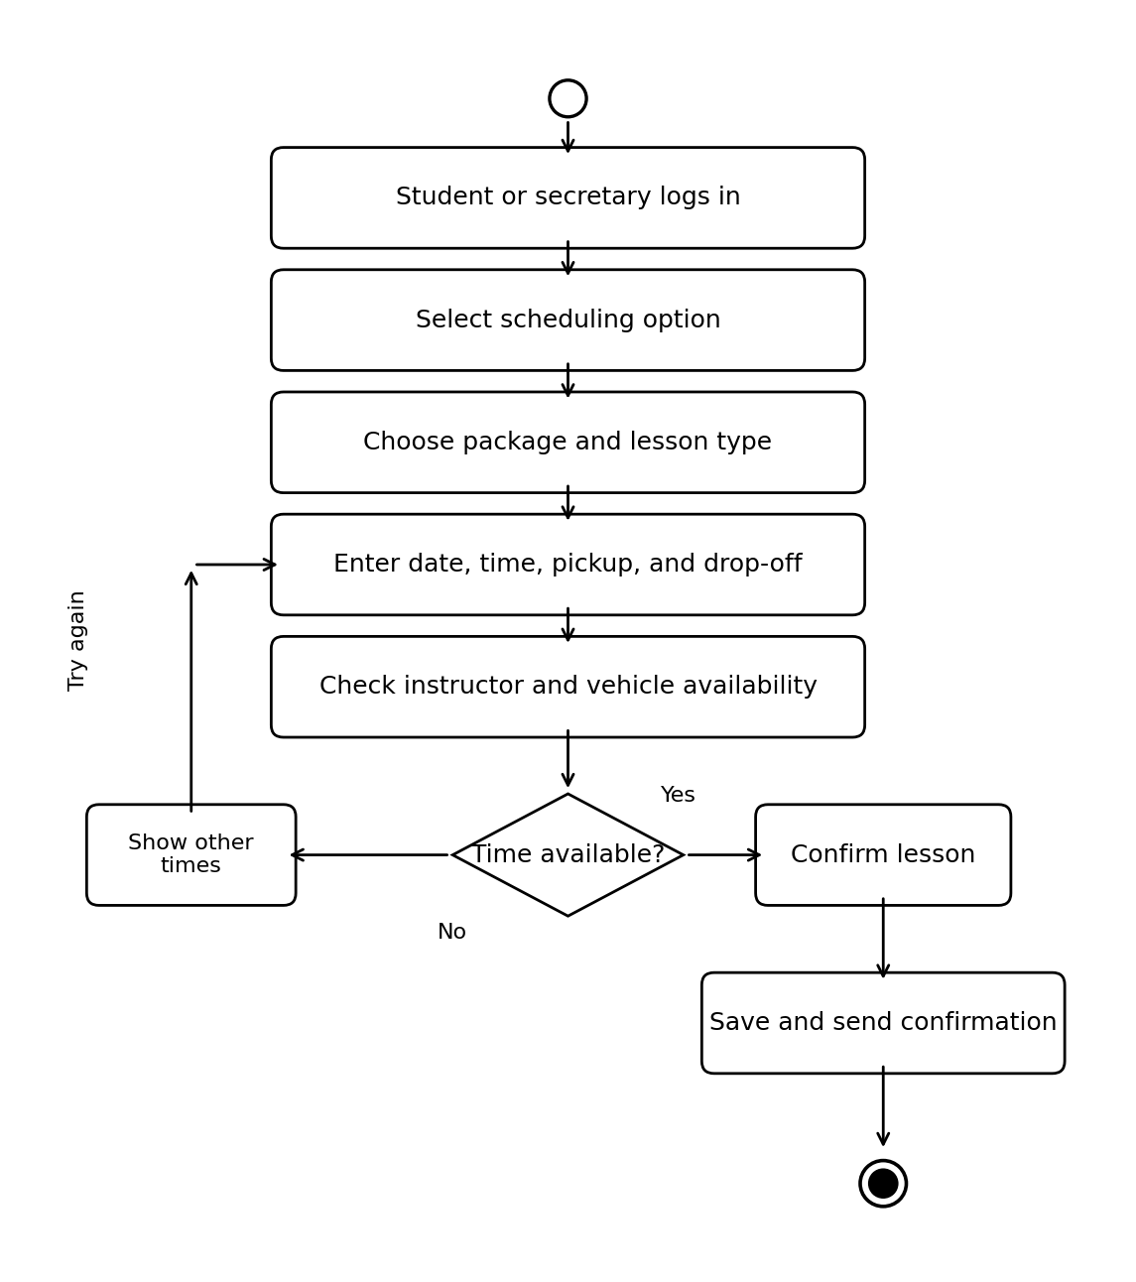
Figure 2. Activity Diagram: Schedule Driving Lesson
The second activity diagram breaks down the process for completing a practice test. This supports DriverPass’s need to provide online study tools and current testing material to customers.
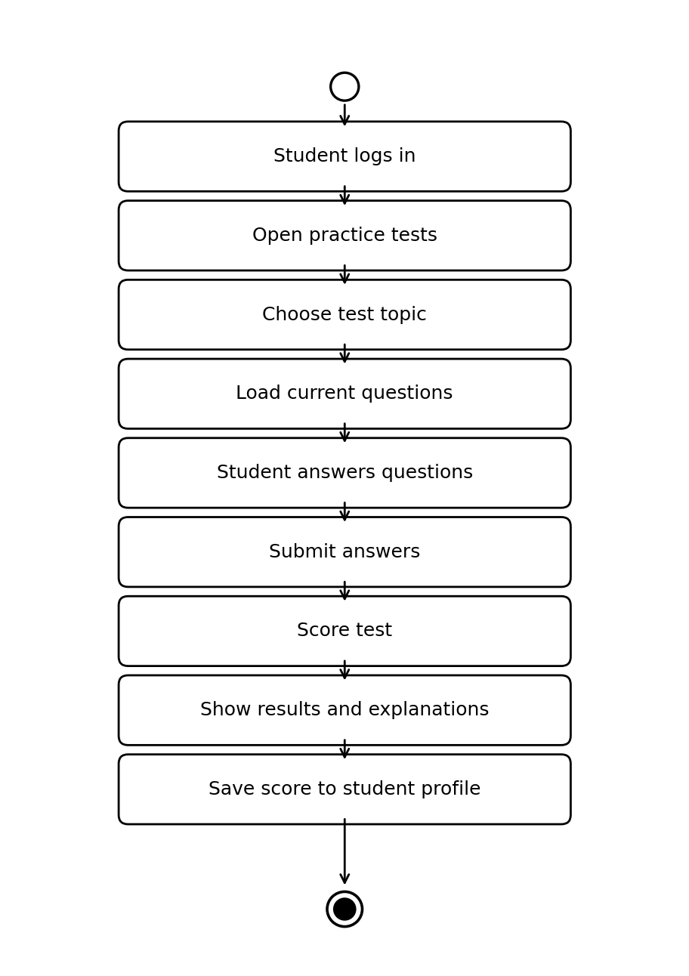
Figure 3. Activity Diagram: Take Practice Test

UML Sequence Diagram
The sequence diagram is based on the schedule driving lesson use case. It shows how the student or secretary submits a lesson request, how the system checks the needed resources, and how the reservation is saved and confirmed.
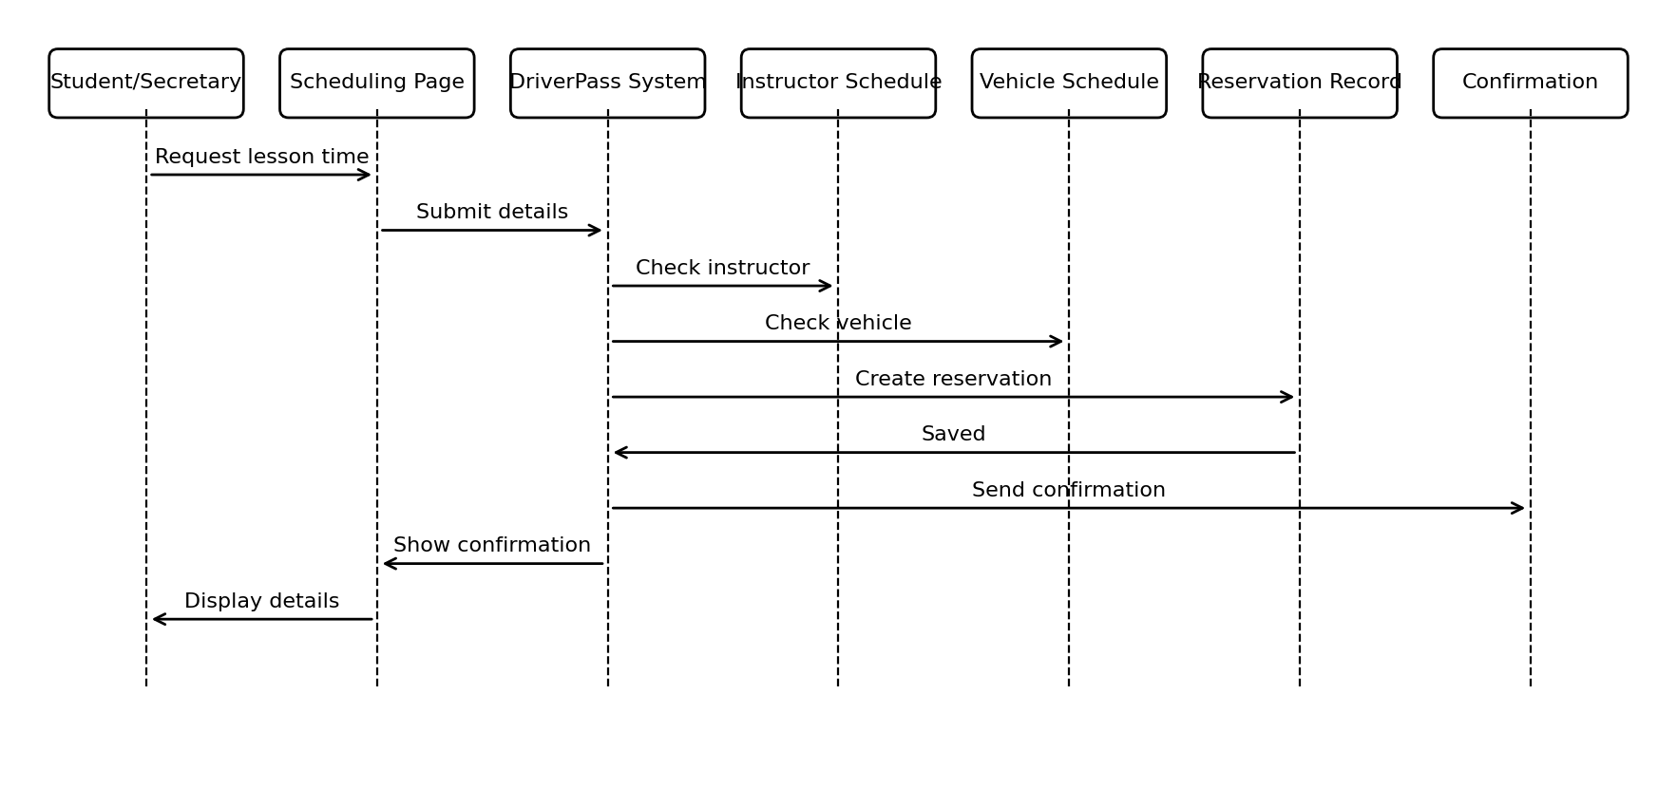
Figure 4. UML Sequence Diagram: Schedule Driving Lesson

UML Class Diagram
The class diagram identifies the main information the DriverPass system must store and organize. These classes include users, students, instructors, packages, lessons, vehicles, practice tests, test results, reports, and DMV updates.
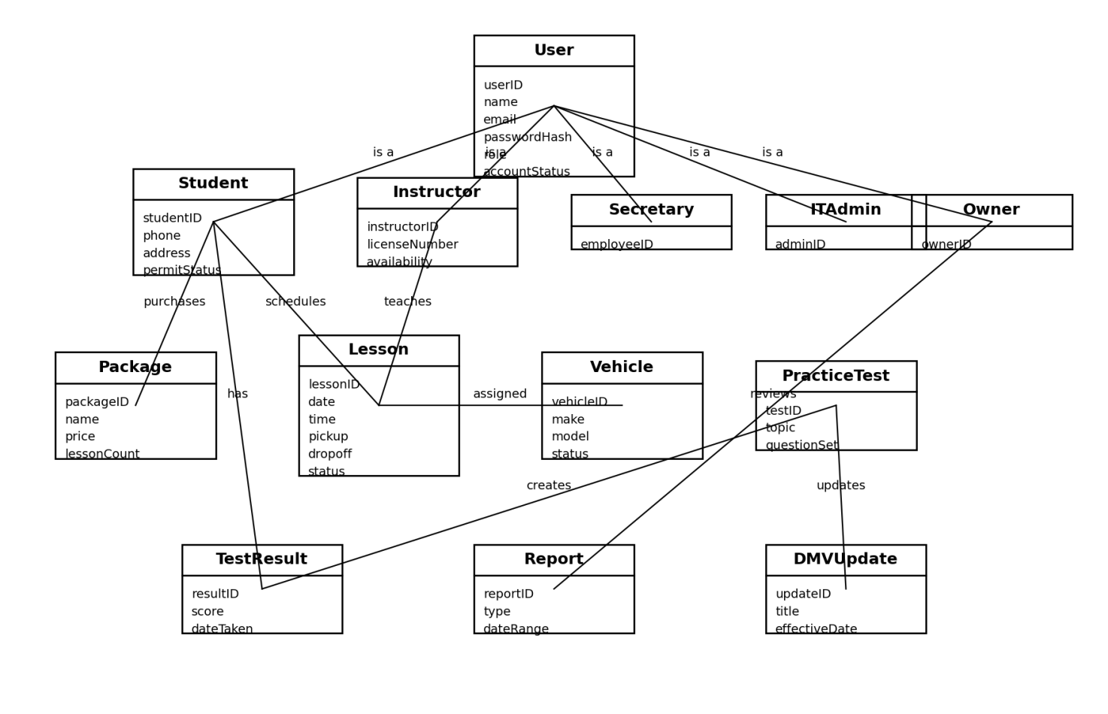

Technical Requirements
The following technical requirements describe the hardware, software, tools, and infrastructure needed to support the DriverPass system design.

Hardware Requirements
• A cloud-hosted web server or managed hosting environment to run the DriverPass website and application services.
• A secure database server to store accounts, lesson schedules, packages, test scores, instructor information, vehicle records, and reports.
• Reliable computers or tablets for the secretary, instructors, owner, and IT administrator to access the system.
• Customer access through common personal devices such as laptops, desktops, tablets, and smartphones.

Software Requirements
• A web-based application that works through modern browsers so users do not need to install a separate desktop program.
• A database management system such as MySQL, PostgreSQL, or another reliable relational database.
• Server-side application software to process login requests, scheduling, package purchases, test results, and reports.
• Administrative software tools for managing user accounts, permissions, system updates, and content updates.

Tools and Development Requirements
• Lucidchart or another CASE tool for maintaining system diagrams during design updates.
• A version control tool such as Git so developers can safely track changes to the system code.
• Testing tools to confirm that login, scheduling, reporting, and practice test features work correctly before release.
• Monitoring tools to alert the IT administrator if the website, database, or login system has a problem.

Infrastructure Requirements
• Secure internet access using HTTPS to protect information moving between the user and the DriverPass system.
• Role-based access so students, instructors, the secretary, the owner, and the IT administrator only see the features they need.
• Regular backups so important data can be restored if there is a system failure or accidental deletion.
• A process for updating DMV information so practice tests and training material stay current.
• Scalable hosting so the system can support more customers and lessons as DriverPass grows.

Security Requirements
• Users must log in with a username and password before accessing private account information.
• Passwords must be stored securely and not saved as plain text.
• The system should lock or temporarily block an account after repeated failed login attempts.
• Users should be able to reset forgotten passwords through a controlled reset process.
• Administrative access should be limited to authorized staff only.

Design Limitations
• This design covers the main system features but does not include every possible screen layout or every minor staff workflow.
• The design assumes users have internet access and a modern web browser.
• The system depends on DriverPass keeping DMV content and lesson availability accurate.
• The initial design may need future updates if DriverPass adds mobile apps, new services, or more business locations.

